**Мартасов Илья, группа ИП-711**

**Лабораторная работа №4**

**1. a)** **F=not (a * b) = not a + not b**

|  |  |  |
| --- | --- | --- |
| **a** | **b** | **F** |
| **0** | **0** | **1** |
| **0** | **1** | **1** |
| **1** | **0** | **1** |
| **1** | **1** | **0** |

**b) F=(not a + not b) * a = not a * a + not b * a**

|  |  |  |
| --- | --- | --- |
| **a** | **b** | **F** |
| **0** | **0** | **0** |
| **0** | **1** | **0** |
| **1** | **0** | **1** |
| **1** | **1** | **0** |

**c) F=not (a + b) xor (not a * not b) = (not a * not b) xor (not a * not b)**

|  |  |  |
| --- | --- | --- |
| **a** | **b** | **F** |
| **0** | **0** | **0** |
| **0** | **1** | **0** |
| **1** | **0** | **0** |
| **1** | **1** | **0** |

**2. a xor b = not a * b + a * not b**

|  |  |  |
| --- | --- | --- |
| **a** | **b** | **a xor b** |
| **0** | **0** | **0** |
| **0** | **1** | **1** |
| **1** | **0** | **1** |
| **1** | **1** | **0** |

**3. C = (a * b) + (a xor b)**

|  |  |  |
| --- | --- | --- |
| **a** | **b** | **C** |
| **0** | **0** | **0** |
| **0** | **1** | **1** |
| **1** | **0** | **1** |
| **1** | **1** | **1** |

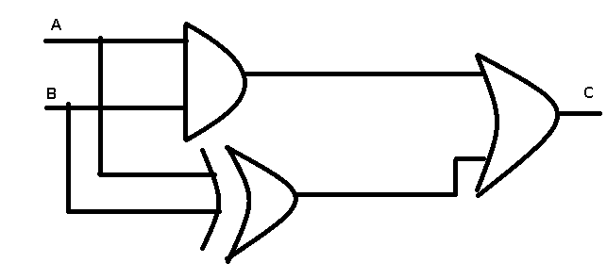

**4. F = (not a * b) + b**

|  |  |  |
| --- | --- | --- |
| **a** | **b** | **F** |
| **0** | **0** | **0** |
| **0** | **1** | **1** |
| **1** | **0** | **0** |
| **1** | **1** | **1** |

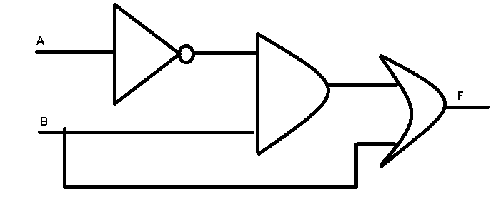

**5. F = (a + b)*not b**

|  |  |  |
| --- | --- | --- |
| **a** | **b** | **F** |
| **0** | **0** | **0** |
| **0** | **1** | **0** |
| **1** | **0** | **1** |
| **1** | **1** | **0** |

